TABLE OF CONTENTS

Contents
1. Introduction 3
1.1 Scope 3
1.2 Related Documents 3
1.3 External Requirements 4
1.4 Internal Requirements 4
1.5 User Interaction and Inferface 4
1.5.1 Milestone 1.0 4
1.6 Design Issues 5
1.7 Current Unknowns 5
2. Class Diagram 6
3. Simulation Class 6
3.1 Grid Class 6
3.2 Wildlife abstract Class 7
3.3 Wildlife Sequence Diagram 8
3.4 Data Structures Inheriting Wildlife 9
3.4.1 Fauna 9
3.4.2 Flora 10
4. Unit Test Strategy 11
5. Additional Information 11
5.1 Future Plans 11
6. References 11
7. Acronyms 11

Introduction
Based on the image provided by the Saskatchewan Wildlife Federation which shows the Saskatchewan food chain, we were tasked with creating a simulation which models the life cycle of animals living in Saskatchewan. The simulation will be able to place animals within a world and update the simulation on a day by day basis to model the wildlife in Saskatchewan.

Scope
This project’s scope includes creating a virtual habitat for the Saskatchewan animals and modeling their life cycle. The simulation is randomly populated when the program starts based on the user’s input. The user will be able to decide how much wildlife is placed into the simulation before the simulation is created. The animals will be allowed to move around the habitat and seek out food to survive. The animals will live or die depending on if they can find prey or if they get eaten by a predator. The simulation will be displayed to the user so that the user can determine what is in each location of the grid at any given step and be able to see the changes in the simulation as it progresses.

Related Documents

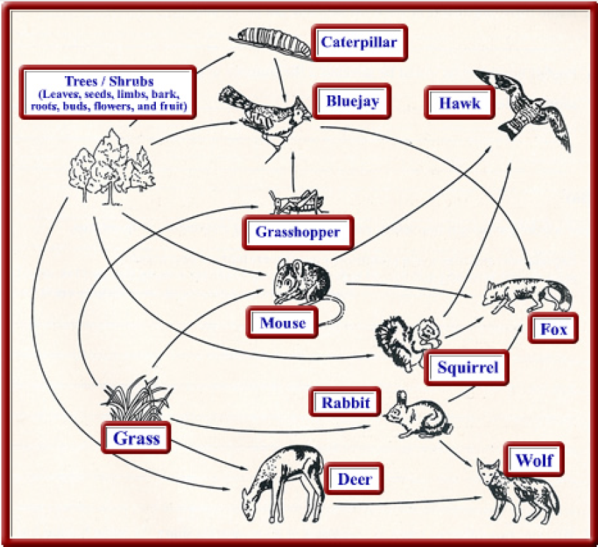
Saskatchewan Wildlife Federation – Saskatchewan Food Chain

External Requirements
When a user interacts with our program, we will require the following inputs:
- The user will be required to input a density that will determine how many instances of wildlife are placed in the simulation
- Once the simulation is created, the user will be able to create a new simulation, display the grid, determine an animal at a given location, step the simulation through one day and exit the program
- The simulation runtime will be able to be controlled by the user.
  - For example, the user should be able to step one day at a time in the simulation.

Internal Requirements
Based on our client’s requirements, the wildlife simulation will follow these requirements:
- The simulation is grid-based.
- The simulation is randomized with animals.
- The simulation is populated based on a given density of animals to place in the grid.
- The simulation is displayed to the user.
- Animals can die from hunger or being eaten.
- An animal can move between the grid spaces.
- Vegetation does not move.
- Animals can move at different speeds.
- Animals do not die from old age.
- An animal will die if it does not eat after a reasonable amount of time.
- When an animal reaches their maximum hunger they will die.
- Two animals cannot be in the same square.
- Not all animals move at the same time. One movement = one day.
- Animals will not run away from getting eaten.
- When an animal moves into another animal’s square it will eat it.
- An animal cannot move into a square as its prey moves out. Predators move first.
- Animals will always move if they can.
- Predators will move to their prey if they have something to eat in a nearby square.
- Animals cannot move outside the grid.

User Interaction and Interface

Milestone 1.0
The user will be able to interact with our program through a user interface that is displayed in the console. When the program starts up, the user needs to determine how densely populated they would like the simulation to be. The user will have to input a percentage value from 0-100 which will determine how heavily populated the simulation will be during the randomization. Once the user has entered this information, the grid will be randomly constructed based on the user’s input density and then the grid will be printed to the screen. Once the grid is displayed to the screen, the user will be prompted with additional commands to control the simulation. The first command will let the user determine what animal is at a specific location in the grid. By calling this function, the user will input x and y coordinates and the program will determine what is at that square in the grid. The second command will print the grid to the screen, allowing the user to see what the simulation has randomly created based on their input. The third command will allow the user to re-create the simulation by entering a different wildlife density. Once this density has been input, the grid will be regenerated and displayed to the user. By selecting this option, the user essentially creates a new simulation since the previous grid will be overwritten. Finally, the last option will allow the user to exit the program once they are satisfied with the results of the simulation. The user interface will not accept any invalid input and if the user inputs a number that is too large, the UI will recognize the invalid input and prompt the user to input something in a correct form.

Design Issues
These are possible issues that we may run into during our development process:
- Finite simulation (the grid is only a specific size)
- User Defined Starting locations for animals via File or UI

Current Unknowns

Question | Solution
How to create the grid to place animals in? | Create a class which holds a 2D array that will randomly create animals. The 2D array will act as the grid and allow for immediate accessing of neighboring grid spaces and also allow for animals to move and get eaten.
How to interact between the animals? | The grid class will be able to detect if there are animals in a nearby square and if there is an animal at that location, the animal’s eat function will be able to decide how to interact based on their movements and ability or inability to eat the animal.
Will we want to use system.out? | System.out will be used to display the grid to the user.
How will we display the grid? | The grid will be displayed by carefully formatting a System.out function in order to display the required characters in the corresponding locations and place the animals display symbol in a particular location in the grid.

Class Diagram
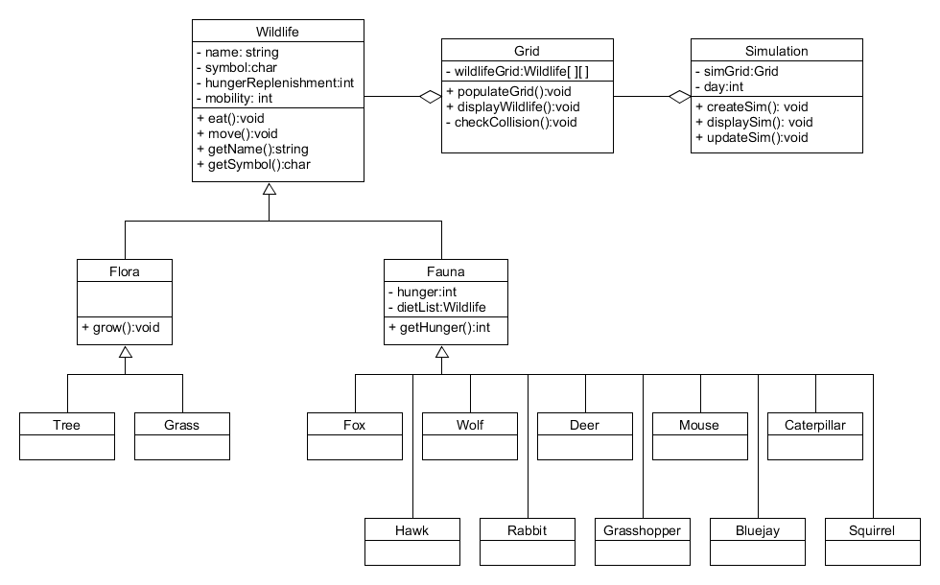

Simulation Class

This class will control the whole simulation. It has variables to determine the current day, and will also be able to display and update the simulation. This class will be able to access a Grid where the wildlife is stored in order to display and update the simulation. This class will act as the User Interface which will display lines to the console for the user to interact with.

Grid Class

This class will hold the map of the simulation. The class will hold a 2D array which will be able to populate the grid, display the wildlife, and be able to detect collisions between animals within the grid. Each position in the array will be instantiated with a member of the Wildlife class and be randomly selected based on a random number generator. The Grid is created randomly based on user input and can be displayed to the screen as well as be able to detect what type of animal is at a given location.

Wildlife abstract Class

public class Wildlife
{
private String name;
private char symbol;

//Default constructor
public Wildlife()
{
this.name = "default wildlife";
this.symbol = '-';
}

//Initializing constructor
public Wildlife(String name, char symbol)
{
this.name = name;
this.symbol = symbol;
}

//Eat function - to be inherited
public void eat(){}

//Move function - to be inherited
public void move(){}

//Name getter
public String getName()
{
return this.name;
}

//Symbol getter
public char getSymbol()
{
return this.symbol;
}
}

The wildlife abstract class will control all of the animals and wildlife that are located within the grid. This class is an abstract class because the functions of this class will all be used or overridden by inherited classes of the different types of fauna and flora that can possibly be created.

Wildlife Sequence Diagram

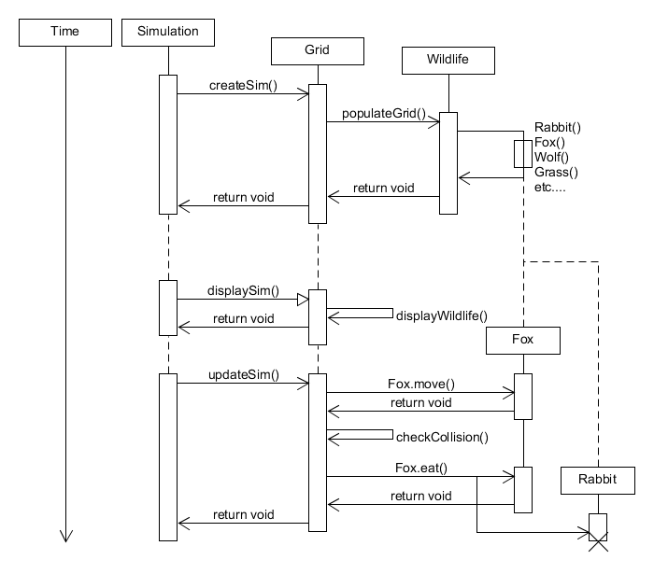

Data Structures Inheriting Wildlife

Fauna

public class Fauna extends Wildlife
{
//This abstract class will eventually be used to store fauna-specific members and methods.
//Potential examples include movement, eating and a list of the fauna's prey.

//Initializing constructor
public Fauna(String name, char symbol)
{
super(name, symbol);
}

//Eat function stub
public void eat()
{
System.out.println("The " + getName() + " is eating.");
}

//Move function stub
public void move()
{
System.out.println("The " + getName() + " is moving.");
}
}

This class is a class that will include all animal types that can be populated in the grid. The animal types are able to move around the grid and eat their prey. This class is able to determine a current animal’s hunger and hold information about what animals they can eat as well as hold their current hunger. The functions that this class uses are overridden from the inherited Wildlife class.

Fox, Wolf, Deer, Mouse, Caterpillar, Hawk, Rabbit, Grasshopper, Bluejay, Squirrel

These classes are all classes that inherit from the Fauna class and will be instantiated in the simulation.

Flora

public class Flora extends Wildlife
{
//This abstract class will eventually be used to store flora-specific members and methods.
//Potential examples include plant growth.

//Initializing constructor
public Flora(String name, char symbol)
{
super(name, symbol);
}

//Eat function stub
public void eat()
{
System.out.println("The " + getName() + " is absorbing nutrients.");
}

//Move function stub
public void move()
{
System.out.println("The " + getName() + " cannot move.");
}
}

The vegetation class will include all stationary animals that will not move. These animals will also not eat any prey and will not populate. Vegetation will only be eaten by the animals present in the simulation. Vegetation will not have hunger. This class overrides some functions from the Wildlife abstract class from which it inherits.

Tree, Grass

These classes are classes that inherit from the Flora class and will be instantiated in the simulation.

Unit Test Strategy

In order to test our simulation, we may perform a variety of automated tests to assert that our functions are working properly. We will also display our simulation to the screen in order to confirm that the grid is properly being created and that the simulation is running correctly. We will also be able to create test functions in order to assert that our functions are properly working.

Additional Information

Future Plans
- Animals and shrubs will repopulate.
- A shrub will replenish increasingly more hunger based on how long it lives.
- The user will be able to control the simulation and be able to step through each ‘day’ of the simulation one at a time.
- May add a feature to populate fauna and flora with different densities to have more flora or fauna.

References

Trevor Douglas
Saskatchewan Wildlife Foundation

Acronyms

